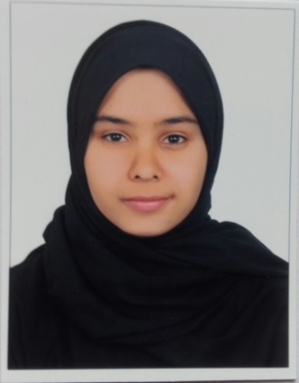

**C.V**

***PERSONAL INFORMATION:***

NAME: Ayat Ebrahim AbdulHusain Jasim Hasan

Personal Number: 981110614

Date of Birth: 30 \11\1998

Nationality: Bahraini

Gender: Female

Marital Status: single

Address: building 4575-Road963-black609

Mobile: 973 39345448

Email: [ayatebrahim998@gmail.com](mailto:ayatebrahim998@gmail.com)

**iver**

***ACADEMIC BACKGROUND:***

Degree: High school diploma

Graduation Year: 2016

University or educational institution: university of Bahrain (2016-2017)

Study specialization: Marketing

***External Certificate:***

Icdl(International Computer Driving License):

***LANGUGES:***

Arabic

English

***Skills:***

Photography

Computer skills